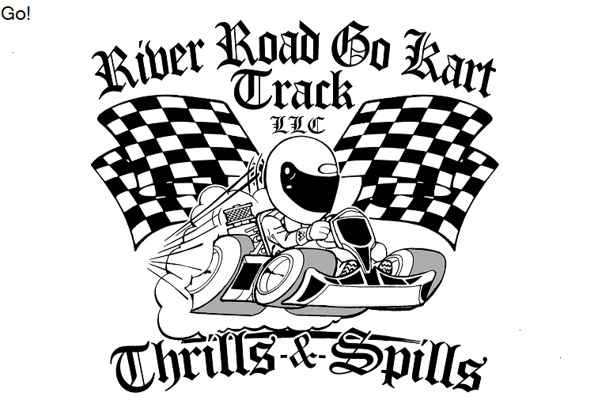
47329 River Road Hammond, La 70401 • 985-351-4576 • 619-419-6781 • rrgokart@yahoo.com
LIABILITY WAIVER
RELEASE OF LIABILITY, WAIVER OF CLAIMS, ASSUMPTION OF RISKS AND INDEMNITY.
BY SIGNING THIS DOCUMENT YOU WILL WAIVE CERTAIN LEGAL RIGHTS INCLUDING THE RIGHT TO SUE.
PLEASE READ CAREFULLY
WARNING: DRIVER WILL BE HELD RESPONSIBLE FOR ANY AND ALL DAMAGE TO PERSONS AND/OR PROPERTY

First Name: __________________________________ Telephone: _________________________________
Last Name: __________________________________ Date of Birth: _______________________________
Address: ____________________________________ Drivers License #:____________________________
City: ______________ State:______ Zip:__________ Email: ____________________________________
- I have full legal responsibility for decisions regarding myself and/or minor child/ward and

- I am familiar with and accept, on behalf of myself and/or my minor child/ward, that there is a risk of serious injury and death in participation, whether as a competitor, student, official or worker, in all forms of motorsport and in particular in being allowed to enter, for any reason, any restricted area; and

- I have satisfied and believe that I and/or my minor child/ward is physically, emotionally, and mentally able to participate in the EVENT, and that my/his/her/protective clothing, gear, and equipment is fit and appropriate for my/his/her use in this EVENT; and

- I understand and will instruct my minor child/ward, that regardless of his/her role, all applicable rules for participating must be followed and that at all times the sole responsibility for personal safety remains with me and/or minor child/ward; and

- I will immediately remove myself and/or minor child/ward from participation, and notify the nearest official if at any time I sense or observe any unusual hazard or unsafe condition of if I feel that I and/or my minor child/ward has experienced any deterioration in my/his/her physical, emotional, or mental fitness, or that my/his/her protective clothing gear or equipment, for continued safe participation in the event.

I UNDERSTAND AND AGREE, ON BEHALF OF MYSELF AND OR MY MINOR CHILD/WARD, HIS/HER/HEIRS/ASSIGNS, PERSONAL REPRESENTATIVE AND NEXT OF KIN, MYSELF, MY HEIRS, ASSIGNS PERSONAL REPRESENTATIVE AND NEXT OF KIN THAT MY EXECUTION OF THIS DOCUMENT CONSTITUTES
- AN UNQUALIFIED ASSUMPTION OF ALL RISKS associated with participation in the EVENT by myself and/or minor child/ward if arising from negligence or gross negligence, including any compounding or aggravation of injuries caused by negligent rescue operation or procedures, of the event organizer, the event venue(s) and of any persons associated therewith or participating therein; and

- A FULL FINAL RELEASEAND WAIVER OF LIABILITY AND ALL CALIMS that I have or may have against any person(s), entities, or organizations(s) associated in any way with the EVENT including the track owners and lessees, promoters, sanctioning bodies, racing associates, or any subdivision thereof, track operators, sponsors, advertisers, vehicle owners, and other participants, rescue personnel, event inspectors, under writers, consultants, and other who give recommendations, directions or instructions, or engage risk evaluation and loss control activities, regarding the EVENT or event premises, or any one or more of them, and their respective directors, officers, employees, contractors, agents and representatives (all of whom collectively referred to as “the releasees”) from any and all liability for any loss, damage, injury or expence that myself and/or minor/ward may suffer, or that his/her next of kin may suffer as a result of his/her use of presence at the event facilities or my child’s/ward’s participation in any part, or presence at, the EVENT, due to any cause whatsoever, INCLUDING NEGLEGENCE, BREACH OF CONTRACT, OR BREACH OF ANY STATUTORY OR OTHER DUTY OF CARE, INCLUDING ANYDUTY OF CARE OWNED UNDER THE RELEVANT OCCUPIERS LIABILITY ACT ON THE PART OF THE RELEASEES; and

- AN AGREEMENT NOT TO SUE THE RELEASEES for any loss, injury, cost or damages of any form or type, howsoever, cause or arising, and whether directly or indirectly from the participation of myself and/or minor child/ward in any aspect of the EVENT; and

- AN AGREEMENT TO INDEMNIFY an to SAVE and HOLD HARMLESS the RELEASEES, and each of them, for any litigation expense, legal fees, liability, damage, award of cost, of any type whatsoever, they may incur to any claim made against them or any one of them whether the claim based on negligence of the releasees or otherwise.

- AN AGREEMENT that this document be govern by the laws of the State in which the EVENT occurs.

I HAVE READ AND UNDERSTAND THIS AGREEMENT AND I AM AWARE THAT BY SIGNING THIS AGREEMENT I AM WAIVING CERTAIN SUBSTANTIAL LEGAL RIGHTS THAT MYSELF AND/OR MY MINOR CHILD/WARD, HIS/HER HEIRS, NEXT OF KIN, EXECUTORS, ADMINISTRATORS AND ASSIGNS AND I AND/OR MY MINOR CHILD/WARD MAY HAVE AGAINST THE RELEASEES.
I SIGN THIS DOCUMENT VOLUNTARILY AND WITHOUT INDUCEMENT.
THIS DOCUMENT WILL REMAIN IN FULL FORCE AND EFFECT FOR ONE YEAR FROM THE DATE OF EXECUTION.

Applicant Name (Print): ____________________________________ Date: __________________________

Applicant Signature: ________________________________ Child/Ward Name:________________________

Driver’s License #: _______________________________ Date of Birth: _____________________________

IN THE CASE THAT PARENT WILL NOT BE ATTENDING EVENT WITH MINOR CHILD/WARD THEY MUST HAVE THIS DOCUMENT STAMPED BY A NOTARY BELOW.

Witness Name: _______________________________ Witness Signature: _____________________________

